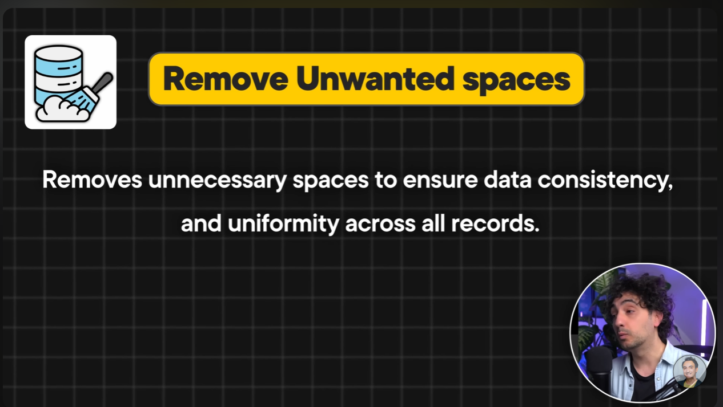

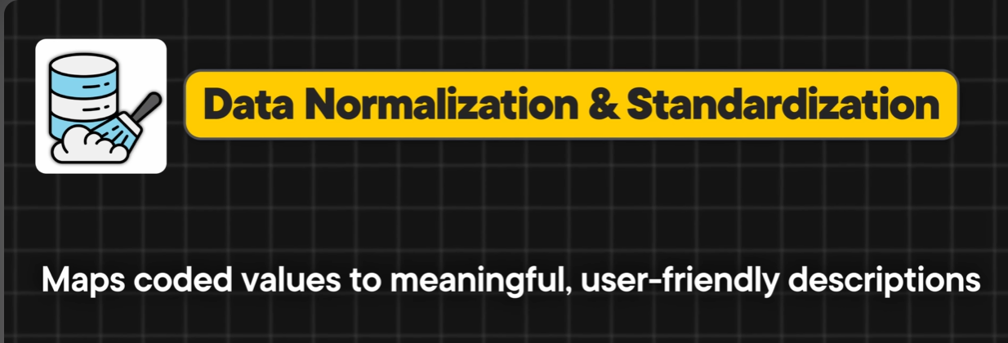

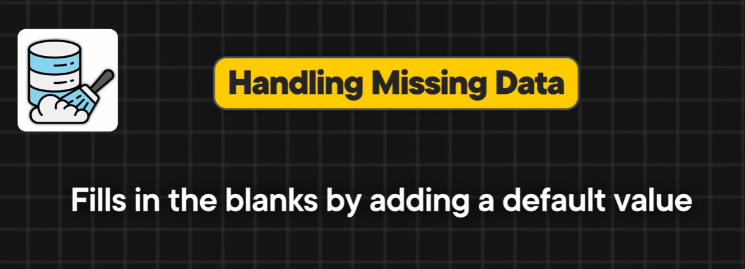

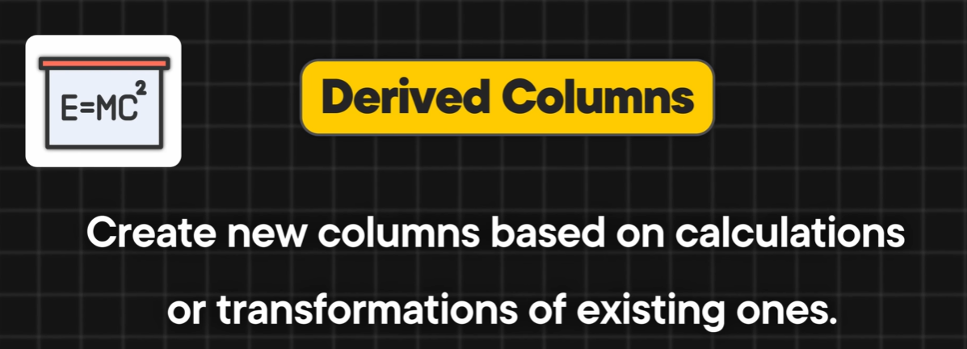

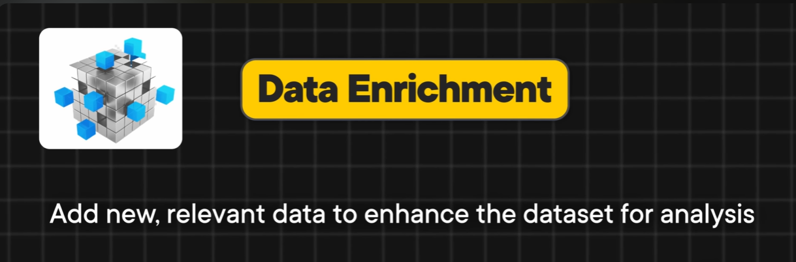
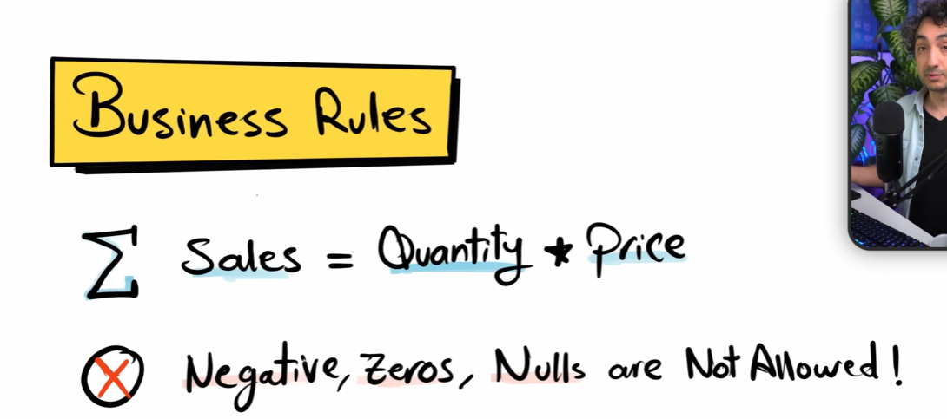

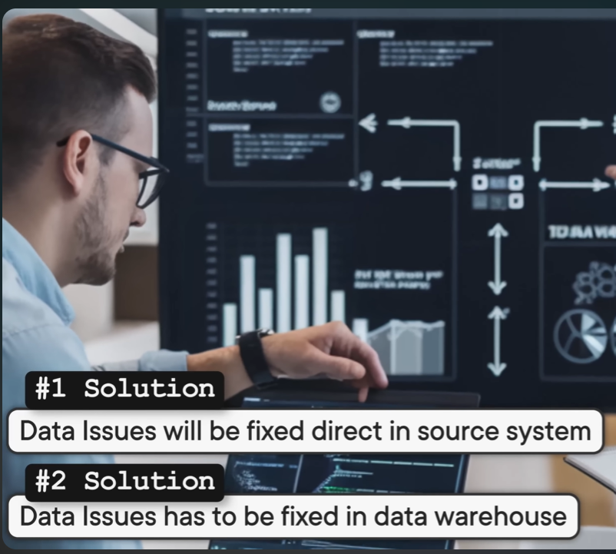

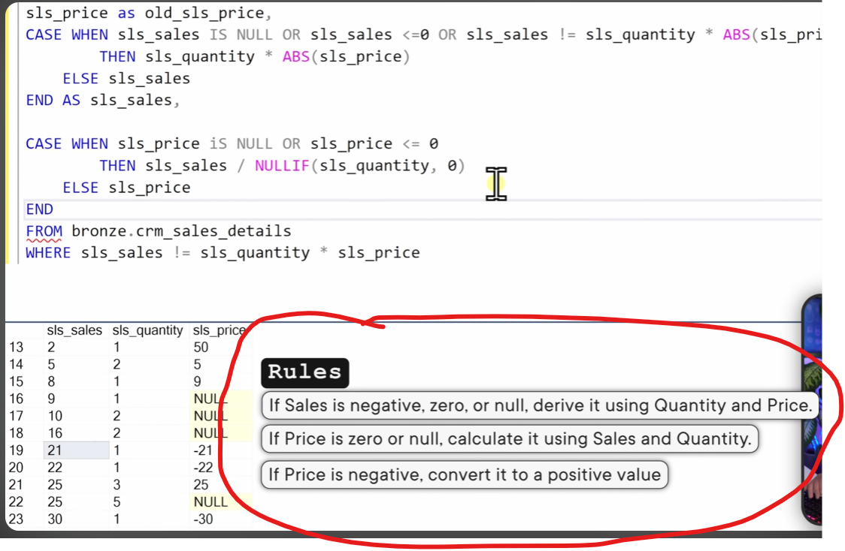

C:\Mukesh\Self-Practice\DE Upskill Practice\Sessions\Session 11 -Tasks\6.SQL Data Warehouse from Scratch\Reference\scripts\silver\proc_load_silver.sql
C:\Mukesh\Self-Practice\DE Upskill Practice\Sessions\Session 11 -Tasks\6.SQL Data Warehouse from Scratch\Reference\tests\quality_checks_silver.sql

